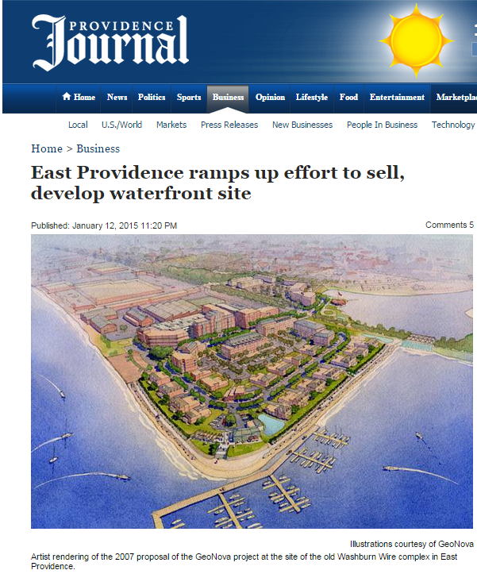
BY PAUL GRIMALDI Journal Staff Writer pgrimald@providencejournal.com
Published: January 12, 2015 11:20 PM
EAST PROVIDENCE — A big chunk of underutilized East Providence waterfront will get a formal push onto the market in the coming weeks as the result of negotiations between the city and a New York real estate company.
An agreement between GeoNova Development Company LLC and the city will put a “for sale” sign on a 27-acre site that once was home to Washburn Wire and Ocean State Steel, according to Providence lawyer W. Mark Russo.
R.I. Superior Court Judge Michael A. Silverstein in September appointed Russo “special master” in a legal case that’s stretched for more than five years between the New York firm and the city.
GeoNova first came to the Rhode Island public’s attention in 2001, when it proposed redeveloping the city-owned site in the Rumford section.
“East Pointe,” the name GeoNova gave to its $200-million plan, was supposed to create nearly 500 condominiums, townhouses and single-family houses, as well as commercial units on a stretch of property on the Seekonk River with panoramic views of the East Side of Providence.
City officials estimated the project would yield up to $3 million in new municipal taxes.
They also expected the project would start a development boom on the waterfront, said Paul Lemont, the city’s acting city manager.
“We thought this GeoNova project would be the first to be developed,” Lemont said. “That’s why we went so hard for GeoNova.”
The U.S. Department of Housing and Urban Development awarded the city a $2-million grant and a $3-million loan to aid with cleanup of the contaminated industrial site.
Construction on the first housing units was supposed to start in February 2004 and the project completed in phases.
The old mill was torn down and the environmental cleanup completed, but the work never progressed beyond that.
“Things just fell apart,” Lemont said.
Exactly when East Pointe was supposed to be finished is one of the primary issues in the legal fight. The most generous interpretation of the documents presented to the court, Silverstein ruled, would mean the project had to be finished by February 2011.
The two sides have been fighting for years over the property’s fate.
“We’re certainly hopeful this is the year we get somebody in there and get the thing going,” said Robert Clark Corrente, the city’s lawyer.
Silverstein named Russo “special master” — a lawyer employed by a court to help resolve complex civil cases.
Russo’s appointment, Corrente said, changed an “adversarial” relationship into one that’s “more or less” cooperative.
“This court-supervised process is a nice model,” Russo said. “This might be a good way to overcome some hurdles.”
After weeks of reaching out to people who might be interested in taking over the moribund project, he is ready to hire a commercial real estate firm to search for a buyer, Russo said.
“We want to dial up the process.”
Lemont, the acting city manager, said the city would welcome a developer who could pick up the GeoNova plan.
East Providence has held off on public infrastructure projects because it doesn’t have the money for them.
“[Revenue] is the thing we need,” Lemont said. “We’ve been fairly stagnant.”
With the national economy perking up, the time may be right to push for a buyer.
Kettle Point, another large-scale project long in the planning, “is going to take off this year,” Lemont said.
Kettle Point is a $75-million, 407-unit development to be set on 40 acres at the southern end of the city’s waterfront district.
Getting development going in the East Providence waterfront could be one of the things that helps Rhode Island out of its economic funk, Russo said.
“I think what happens in the Providence Knowledge District and the [East Providence] waterfront district is very critical to our economy,” Russo said.
Lemont said, “It would hopefully say to outside investors that Rhode Island is a good place to invest in.”

